The following are the results of an investigation into the properties of the M7 diode as a pseudo PIN diode when used to switch Lo Pass TX filters at up to 50 Watts of power in the range 1.0 MHz to 60 MHz. Readings above 1.8 MHz and below 54 MHz are relevant to Amateur Radio HF operation.

A photograph of the test jig and the circuit used (Fig 1) are shown below. The test jig was constructed on ordinary phenolic PCB with lands milled out with a dremmel tool using a 10mm diameter rotary saw blade. All choke cores were BN42-2402 and were tested wound on a single core shown lying on the PCB or in a stack of 2 for greater core area.
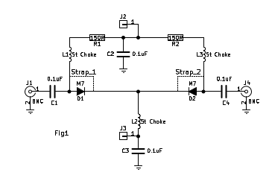

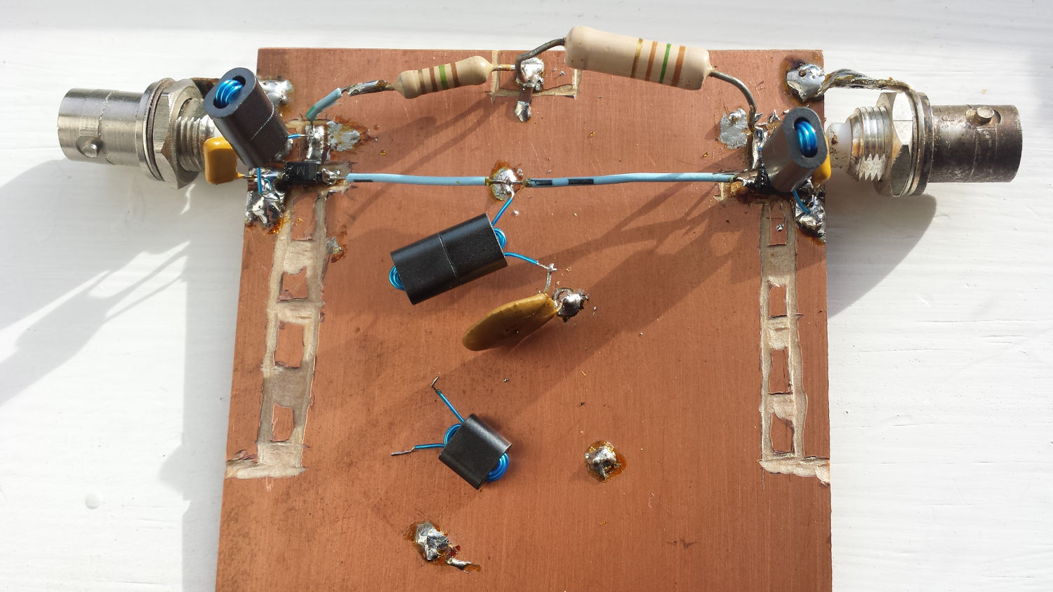

Tests were conducted to investigate the following
- The effect on the frequency response due to the number of turns on the choke.
- The effect on the frequency response of the number of cores in the choke.
- The effect on the frequency response of the bias current through the chokes.
- The attenuation introduced by the diodes when forward biased.
- The attenuation introduced by the diodes when reverse biased.

Strap_1 and Strap_2 were applied so the diodes were shorted and had no effect on the results. A selection of chokes were wound and the results shown in the table. For the current through the chokes tests 9 volts was applied to J1 and J2 to provide 60 mA bias current.
- Examining the first pair of readings, row 1 establishes the base readings with the losses attributed to the shunt losses of the chokes. Row 2 shows the additional loss caused by the bias current through the winding saturating the core. As expected the loss is higher at low frequencies where the magnetic core affects the inductance more.
- In the second pair of readings one of the chokes was substituted with a 2 core choke and it i seen that the magnetic loss due to the DC bias current is less resulting in less through loss.
- In the third pair of readings the 2 core choke had one turn removed but this obviously left it with too little inductance
- In the fourth pair of readings 2 of the chokes were changed to 2 cores of 4 turns with an accompanying improvement.
- The fifth pair of readings was with all chokes changed to 2 cores with 4 turns on each which resulted in the least attenuation of the through path so far,
- At the 6th set of readings I tried going to a single core at the centre (L2) position as it corresponds to the one needed with every filter and as there was going to be many of them I wanted to use as few cores as possible for both cost and space. The loss is greater but may be acceptable.
- For the 7th pair of readings I tried 2 cores with 5 turns on the centre choke (L2) and there was a good improvement suggesting I was still short of inductance in my chokes.
- The 8th pair of readings was with 2 cores containing 5 turns and this gave the best result so I ran some tests with forward and reverse bias as shown in the green background readings on the table. For these tests Strap_1 and Strap_2 were removed so the diodes were in circuit and could provide an on and off condition for the through passband.

Test condition | Bias | 1.8MHz | 14MHz | 30MHz | 50MHz
3 x Single core 7t chokes | N | -0.50 | -0.33 | -0.09 | -2.23
3 x Single core 7t chokes | Y | -1.35 | -0.46 | -0.19 | -2.33
1 core of 7t at L1 & L3 and 2 cores of 4t at L2 | N | -0.50 | -0.36 | -0.14 | -2.29
1 core of 7t at L1 & L3 and 2 cores of 4t at L2 | Y | -1.22 | -0.46 | -0.20 | -2.35
1 core of 7t at L1 & L3 and 2 cores of 3t at L2 | N | -0.65 | -0.44 | -0.19 | -2.34
1 core of 7t at L1 & L3 and 2 cores of 3t at L2 | Y | -1.43 | -0.55 | -0.26 | -2.38
1 core of 7t at L1 and 2 cores of 4t at L2 & L3 | N | -0.52 | -0.36 | -0.14 | -2.29
1 core of 7t at L1 and 2 cores of 4t at L2 & L3 | Y | -1.11 | -0.46 | -0.19 | -2.34
3 x Double core 4t chokes | N | -0.60 | -0.38 | -0.13 | -2.27
3 x Double core 4t chokes | Y | -1.10 | -0.46 | -0.18 | -2.32
1 core of 7t at L2 with 2 cores of 4t at L1 & L3 | N | -0.60 | -0.36 | -0.11 | -2.24
1 core of 7t at L2 with 2 cores of 4t at L1 & L3 | Y | -1.25 | -0.46 | -0.16 | -2.29
2 core of 5t at L2 with 2 cores of 4t at L1 & L3 | N | -0.56 | -0.33 | -0.08 | -2.18
2 core of 5t at L2 with 2 cores of 4t at L1 & L3 | Y | -1.02 | -0.40 | -0.11 | -2.20
3 x Double core 5t chokes | N | -0.42 | -0.29 | -0.08 | -2.20
3 x Double core 5t chokes | Y | -0.83 | -0.36 | -0.13 | -2.25
3 x Double core 5t chokes Fwd biased to 65 mA | Y | 0.94 | -0.40 | -0.15 | -2.24
3 x Double core 5t chokes Rev biased with 9 V | N | -70.37 | -32.54 | -26.5 | -18.61
3 x Double core 5t chokes Rev biased with 20 V | N | -73.47 | -34.95 | -38.82 | -21.23
3 x Double core 5t chokes Rev biased with 33.3 V | N | -81.39 | -36.74 | -30.58 | 23.13

The 2 VNA plots made with quisk_vna describe the circuit reversed biased with 9 volts in the upper plot and forward biased with 65 mA in the lower plot. The reverse bias is a worst case presentation as the voltage presented to the diode in a normal setup with multiple filters with at least one turned on would be supply voltage (13.6v) less a diode voltage drop (0.7v) leaving 12.9v of reverse bias.

It would seem that the floor of a filter would be around 26 dB at 30 MHz due to the through filter only providing that much attenuation at that frequency because of the capacitance of the reverse biased diode but as will be seen later the filters absorb this stray capacitance and things are pretty good.

The M7 diode has been well characterised by Andrea Montefusco and can be found at http://www.qsl.net/in3otd/electronics/PIN_diodes/M7.html I recommend that you visit this site and be prepared to spend at least an evening browsing the site which holds a mountain of valuable information and tests performed. I was delighted to see that my results mirrored that of Andrea with the difference being that mine had 2 diodes in series and an extra choke in circuit with commensurate results.
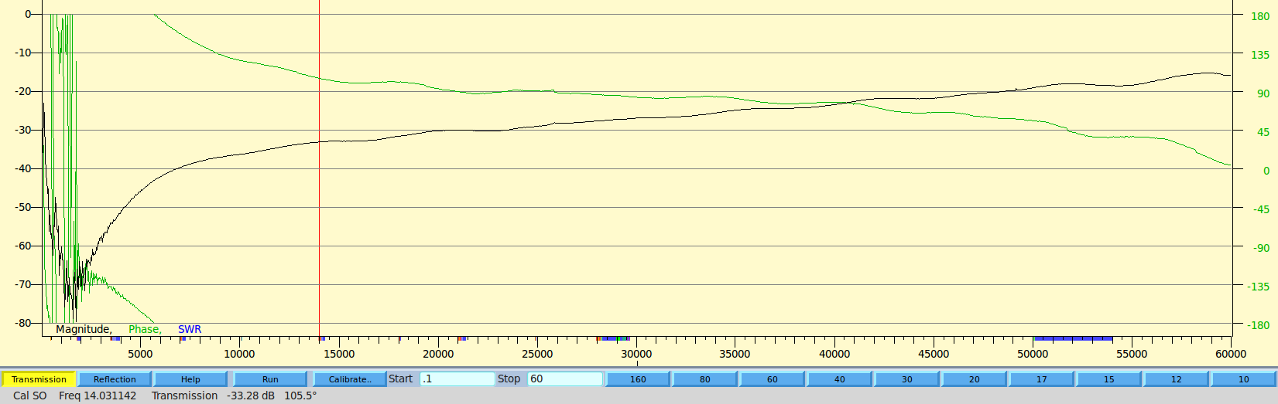
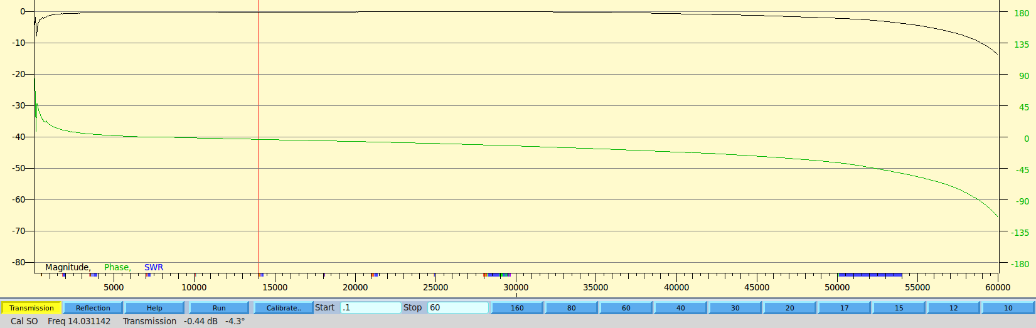

The next step – Making a practical switched filter and testing it.
The test board was extended to contain the original through connection plus a 20M Lo Pass filter as shown in the circuit below. The filter was lashed up from junk box parts with no attention paid to COG or high tolerance capacitors and the inductors were wound to occupy 80% of the core.

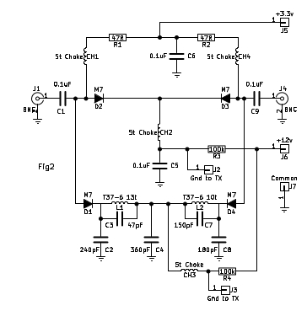
The diodes have +3.3v applied to forward bias them through J5 and either J2 or J3 to ground. The action of grounding either J2 or J3 also shorts out the +12v via R3 or R4 which had been reverse biasing the diodes thus the path can be switched either straight through via D2 and D3 or through the 14.4 MHz LP filter via D1 and D4.

Testing the switching and power handling of the test unit
The circuit was tested for through path loss and then through the filter loss with results shown below. The filter loss was nearly identical to the filter on its own and the lack of attenuation as the frequency goes beyond 30 MHz is likely due to layout and stray coupling and can only be verified with a proper PCB layout but is good enough as it is because the final circuit will have a 30 MHz roofing filter on both the Tx and Rx paths.

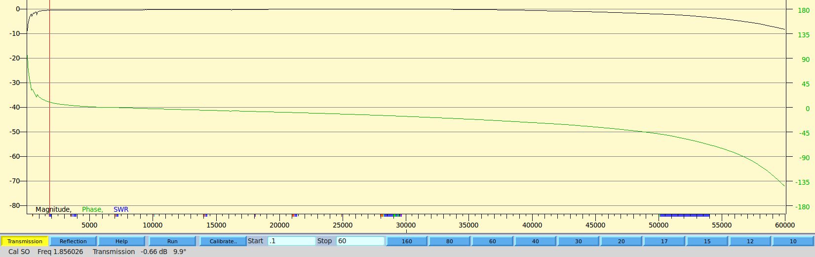
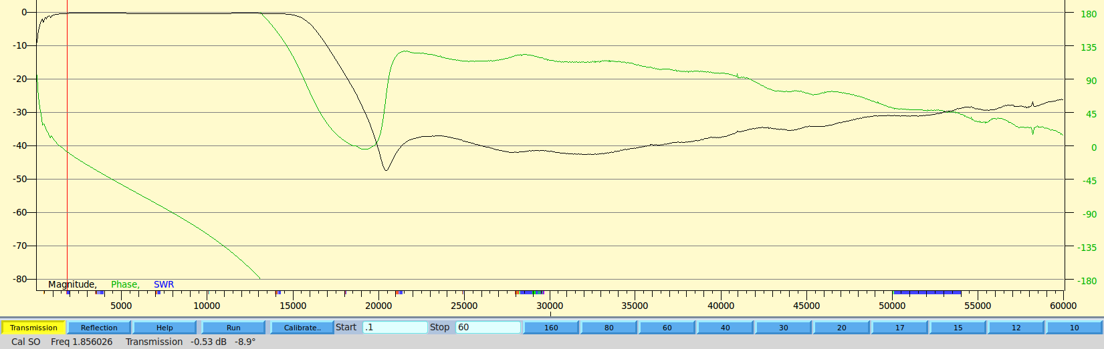
The return loss is not affected by switching through the diodes and is shown below along with a picture of the haywired test board.

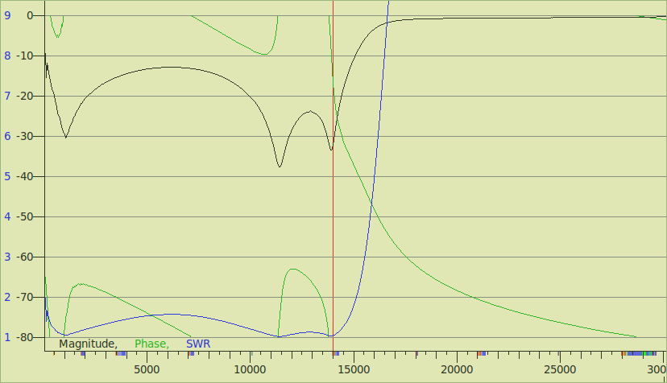
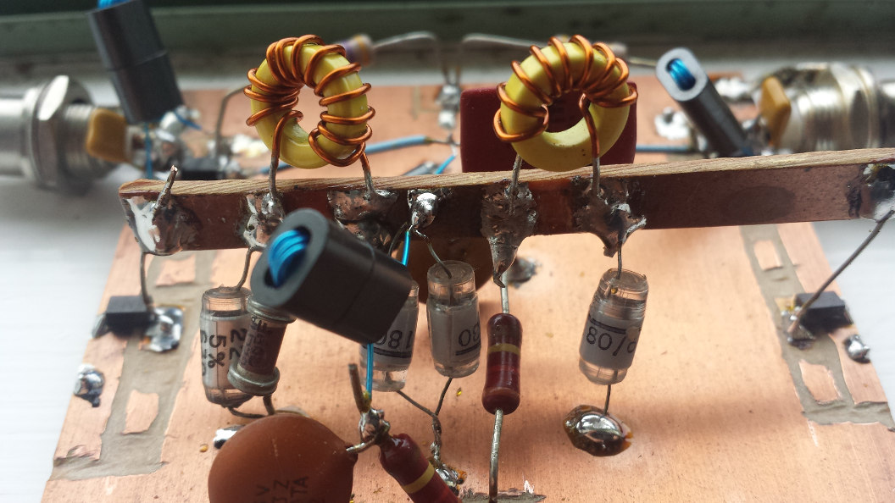
Finally the system was tested with RF applied. 5 watts gave perfect operation with 4.5 watts out of the filter as predicted. Twenty watts started to warm the chokes but hardly raised the toroid temperature. I needed to touch with my lip to detect any rise. At 50 watts the toroids were slightly warm to the touch but the chokes got too hot to touch. I guess I need to improve them but the diodes and the rest of the circuit held up fine with a 10 minute sustained signal.

